Contents

1. Visitor 2

1.1. Search 2

1.2. Advanced Search 2

1.3. Delete Post 3

1.4. View Post 3

1.5. Add Post 4

1.6. Edit Post 4

1.7. Register 5

2. User 5

2.1. Login 5

2.2. View User Profile 6

2.3. Edit User Profile 6

2.4. Manage Post 7

2.5. Manage Favorites 7

2.6. Add Post to Favorite 7

2.7. Remove Post from Favorite 8

3. Admin 8

3.1. Add new Categories 8

## Visitor

### Search

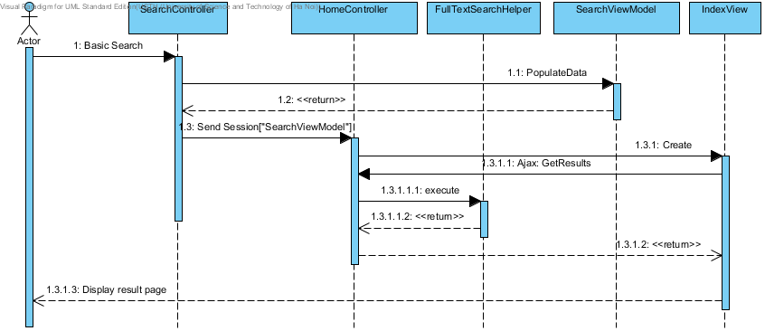

### Advanced Search

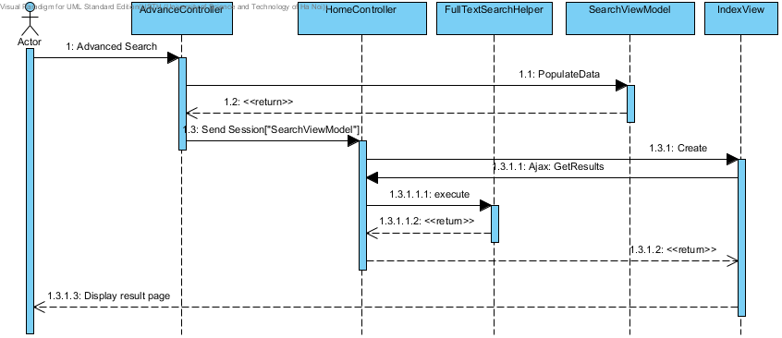

### Delete Post

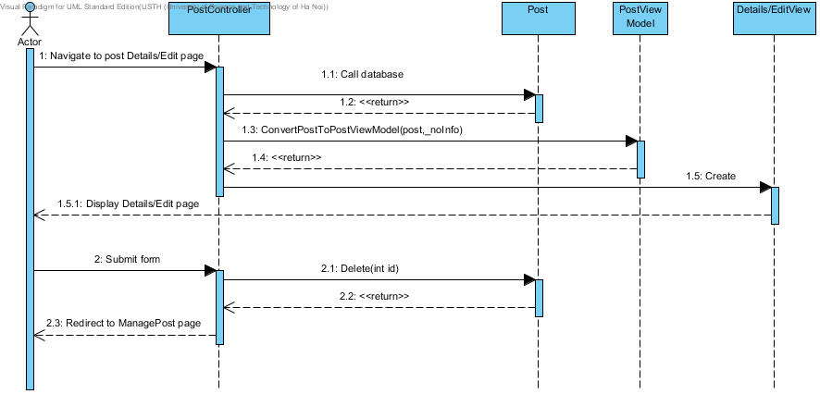

### View Post

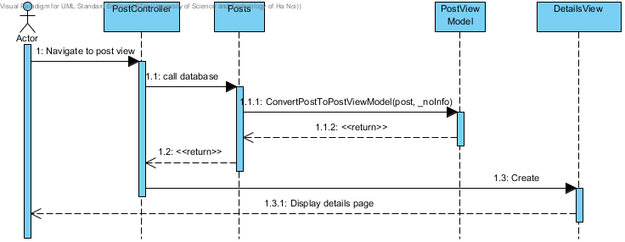

### Add Post

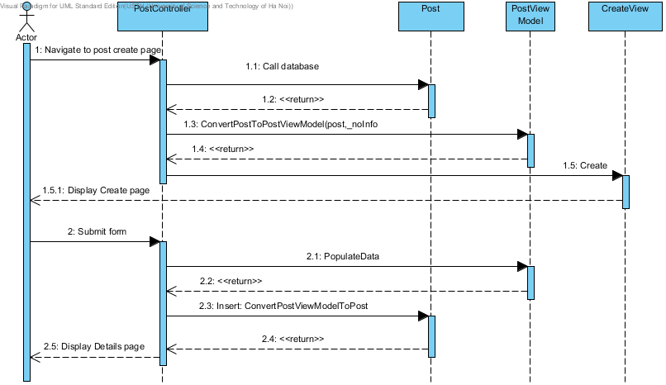

### Edit Post

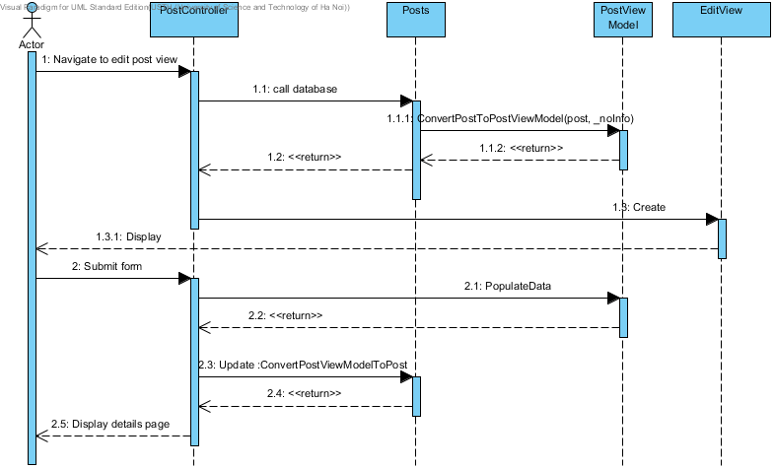

### Register

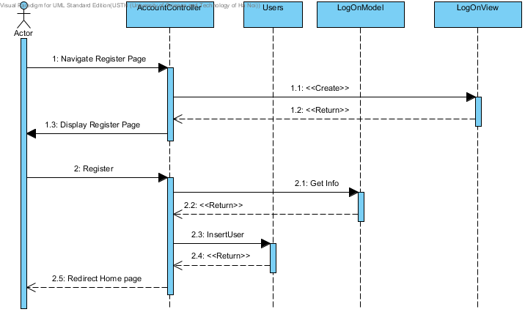

## User

### Login

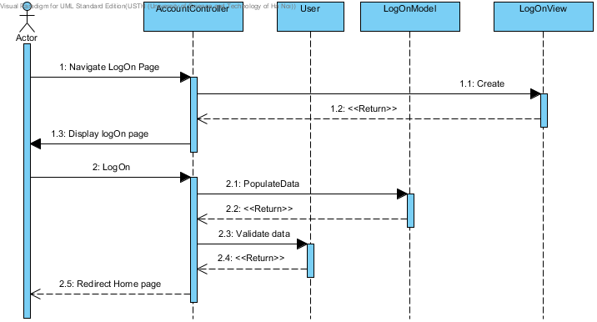

### View User Profile

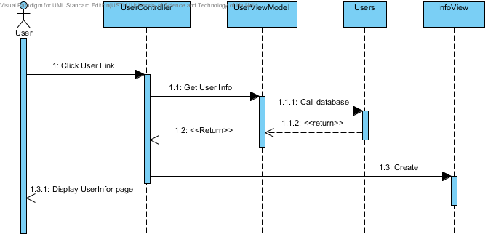

### Edit User Profile

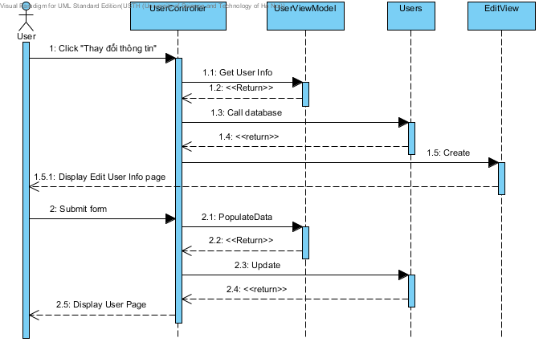

### Manage Post

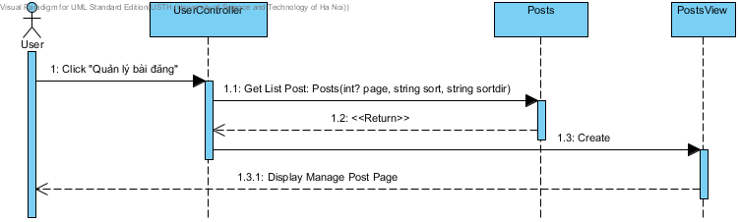

### Manage Favorites

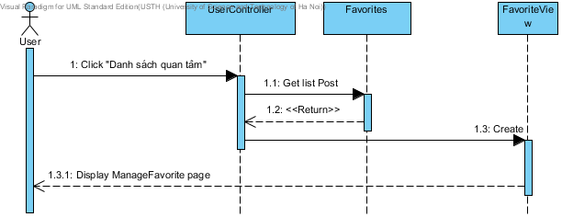

### Add Post to Favorite

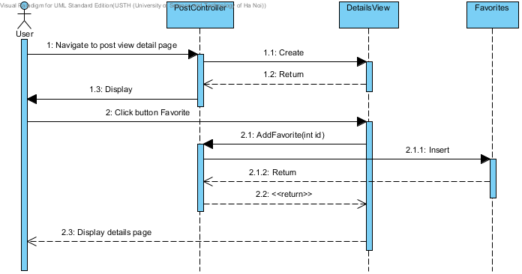

### Remove Post from Favorite

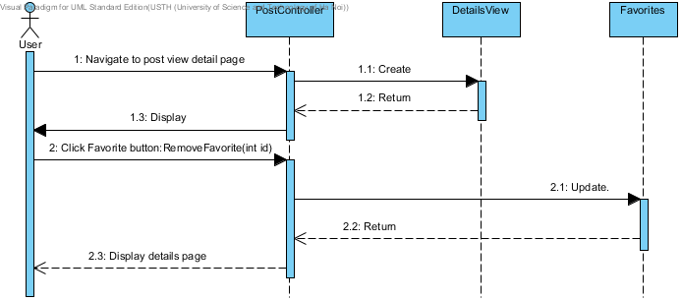

## Admin

### Add new Categories

